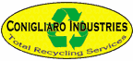 | Conigliaro Industries, Inc.  701 Waverly Street  Framingham, MA 01702  (888) CONIG-25 | (508) 653-6672 fax  http://www.conigliaro.com | mailto:sales@conigliaro.com

Driving Directions

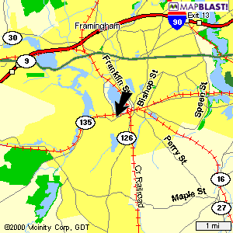

From the Massachusetts Turnpike:
Take Exit 13, "Route 30, Framingham/Natick". Go through the tolls, bear right onto Route 30 West. Follow until you intersect Route 126 after going by the Framingham mall on the right. Take a left onto Route 126 towards Framingham center. Follow all the way to Route 135 in the center at the railroad tracks. Take a right onto Route 135 West "Waverly Street". Go through one set of lights at the Gulf station, then turn right into "Northeast Electrical Distributors Plaza" (this is only 1/4 mile from Route 126). Conigliaro Industries' entrance may be found between E-Zee Rental and New England Compounding Center in the plaza.

From Route 9:
From Boston head west, go past the Natick Mall, Ken's Steak House and Caldors Plaza, up over a hill. Then take Route 126 towards Framingham center (you have to go under the overpass to take this Route 126 exit off Route 9). Follow all the way to Route 135 in the center at the railroad tracks. Take a right onto Route 135 West "Waverly Street". Go through one set of lights at the Gulf station, then turn right into "Northeast Electrical Distributors Plaza" (this is only 1/4 mile from Route 126). Conigliaro Industries' entrance may be found between E-Zee Rental and New England Compounding Center in the plaza.

From Route 128:
Take Route 128 to Route 9 West, then follow the directions above or take Route 128 to Mass Pike West, then follow the directions above.

Truck Entrance:
Trucks enter from rear off Fountain Street. Fountain Street is at the lights next to the Gulf station. Our back entrance is 100 yards up Fountain Street from the Gulf station.

